C.V
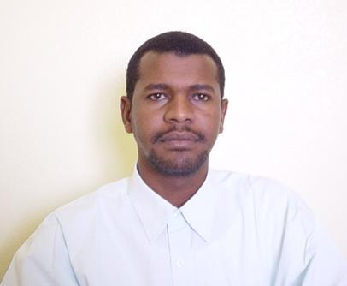

Personal Information:
Name: Ahmed A. M. Hamed
Place of birth: Khartoum
Date of birth: 15 Sept 1973
Marital status: Married
Nationality: Sudanese
Languages: Arabic (Excellent in speaking, reading and writing)
English (Excellent in speaking, reading and writing)
Chinese (Fair in speaking, reading and writing)
Address: Block 15, No 43, Alkalakla Alwihda, Khartoum, Sudan
Phone: +249122994849
E-mail: ahmedhmed@gmail.com

Academic qualification:

- Doctor of Engineering In Computer Science and Technology Hunan University, PRC, April 2016.
- M. Sc. in Computer science, University of Algazira September 2007.
- B.Sc. in Computer science and Information systems, Sudan University of Science and Technology 1998.

Hobbies:
Playing football, Travelling, Watching movies, and reading.

Work experience:

  - General directorate of planning, ministry of higher education and scientific research, Khartoum, Sudan from Sept 1998 to Oct 1999.
Duties:
- Follow up higher education information system with the company that established the program.
- Supervision of the connections of institutions equipments and network of higher education.
- Supervision of the continues maintenance of computers and network of the directorate.
  - Teacher and computer lab supervisor in ministry of education, Aldwadmi directorate, Saudi Arabia from Nov 1999 to July 2004.
Duties:
    - Teach computer curricula of general education
    - Work as co-supervisor in computer center of directorate
    - Supervision of 42 school computer labs of directorate.
    - Participate in committees that receipt the computer labs form different companies.
  - Teaching assistant at computer studies center, Juba university form Nov 2004 to Sept 2007.
Duties:
    - Assist teaching (tutor) different courses for 3 years diploma students
    - Work examination officer, as administrative job.

  - Lecturer at computer studies center, Juba university form Sept 2007 to2009.
    - Teaching different computer courses such as introduction to computer, data structure, computer ethics, computer networks, programming languages, ..etc.
    - Work as head of Information Technology department from 2007to 2009
    - Work as post-graduate coordinator from 2008 to 2009.
5. Assistant Professor, College of Computer Sciences, Bahri University from August 2016.

Published work:
1- Ahmed A. M. Hamed, Zhang XM, Cheng Xu, Li Renfa, " Video Genre Classification Using Support Vector Machine Ensemble ", International Journal of Digital Content Technology and its Applications (JDCTA), 6(15), pp. 191 ~ 200, 2012. (EI)
2- Ahmed A. M. Hamed, Zhang XM, Cheng Xu, Li Renfa, "Video Genre Classification Using Weighted Kernel Logistic Regression", Advances in Multimedia, (2013), 2013. (EI)
3- Tamer Galal Moursi Farag, Sun Xingming, Yang Gaobo, Ahmed A. M. Hamed, "Video Resizing Using Seam Carving and Object Detection", International Journal of Digital Content Technology and its Applications (JDCTA),7 (8), pp.157~164, 2013.
4 - Asogwa, C.O. and Zhang, X. and Xiao, D. and Hamed, A., A.,” Experimental analysis of AODV, DSR and DSDV protocols based on wireless body area network ”, Communications in Computer and Information Science,312, pp. 183~191. 2012

References:
- Professor Shambol Adalan Mohammed, Dean, faculty of engineering, Sudan University of science and technology, Khartoum, Sudan, mobile: +249912304760.
- Dr. Yahia Abdallah Mohammed, Minister of Telecommunication Ministry, Khartoum, Sudan, mobile: +249912224260.

