**Curriculum vitae**

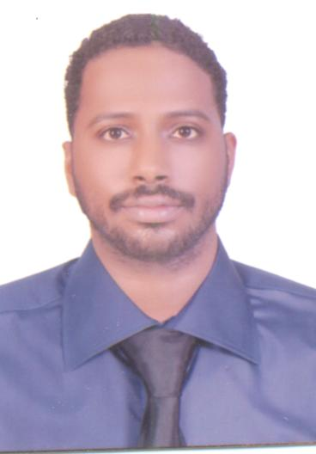

**Personal Information**

***Name: Siddig Mustafa Mohammed Suliman***

***Gender: Male***

***Nationality: Sudanese***

***Date of Birth: 16-07-1987***

***Place of Birth: KHARTOUM- SUDAN***

***Marital Status: Married***

***Religion: Muslim***

***Address Khartoum - Sudan***

***Phone number: 00249912102896***

***E-mail: siddigmustafa1@gmail.com***

***Passport No. P00661078***

**Qualification**

* **Education:**

***Secondary school Alkalkla NMZ. 2004 SUDAN***

***Honor Degree Qualification Certificate in Medical Laboratory Science. SUDAN***

***Third Class BSc in Medical Laboratory Science, Alneelain University ( clinical chemistry Department ) Date of Award September 2010.SUDAN***

***M.S.c degree in medical laboratory sciecnce – clinical chemistry 2015.***

**Professional Experience:**

* **Aug 2012 – 2016 : Medical Technologist Laboratory Department Elshifa Specialized Hospital (SUDAN)**
* ***Carry full responsibility for training and updating junior staff members, supervising all results and reports before dispatch and keeping log books for reports, results and maintenance. Uses sterile techniques to avoid contaminating lab experiments.***
* ***Monitor inventory levels and materials and supplies in accordance with established policies and procedures***
* ***Following policies and procedure for infection control and facility safety in accordance to hospital guidelines. Maintains accurate data records.***
* **Oct 2010 – Oct 2011 :teaching assistant at al neelain university faculty of medical laboratory science (SUDAN)**
* **Teaching staff**
* **Dec 2010 – Oct 2011: General administration of medical services in ministry of defense hospital as medical laboratory technologist (SUDAN).**
* ***Apply scientific methods in problem solving and assist in the evaluation of new methods and techniques.***
* ***Follow clinical laboratory testing procedures and policies in the performance of routine and specialized tests.***
* **Devises that I worked on :**
* ***Bio bas-1*** *for partial thromboplastin time and prothrombin time.*
* ***CORNlEY AFT-300*** *electrolyte analyzer.*
* ***BS-120, BA-88A and BS200 chemistry*** *analyzer.*
* ***SYSMEX KX-21N for*** *complete blood count.*
* ***ICHROMATM*** *for hormones.*
* **Licenses:**
* ***Permanent Registration License from Sudan National Medical and Health Professional council Sudan.***
* **Language Skill:**
* ***Arabic Language (Mother Language)***
* ***English Language (Writing, Reading and Speaking)***