**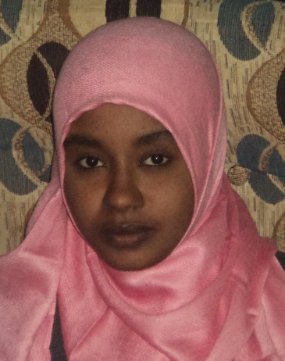*Curriculum Vitae***

**Personal Information:**

Name: Hana Saeed Mahgoob Mohamad

Birth date: 17 July 1990

Gender: Female

Nationality: Sudanese

**Contact Information:**

Email address: hanasaeed2000@gmail.com

Address: Khartoum-Jabra block 8, house No -39

Country: city: Sudan, Khartoum

Mobile phone numbers (Sudan):0115221980-0912629751-0114588158.0905700867

**Education:**

Certificate: ***B.SC,* Very Good Honor degree Medical Laboratory Science.**

University: Omdurman Islamic University.

Specialty: Microbiology.

Location: Omdurman, Sudan.

Completion date: 24 December 2011

Certificate: ***M.SC, Excellent degree* in Medical Laboratory Science*.***

University: Omdurman Islamic University.

Completion Date: 8 February - 2016

Location: Omdurman-Sudan.

**Courses and training:**

* **Course name:** Quality standards ISO 9001 &ISO 17025:2005 for laboratory.

Institute: Alroia Alsabaa for Management Training & Human Resources Development.

* **Course name:** A Systems approach to measuring Medical Laboratory Performance.

Institute: Alroia Alsabaa for Management Training & Human Resources Development.

* **Course name:** ISO 15189:2012 Medical laboratories- Requirements for Quality and competence.

Institute: Alroia Alsabaa for Management Training & Human Resources Development.

* **Course name:** Risk Management in Medical Laboratories ISO 3100.

Institute: Alroia Alsabaa for Management Training & Human Resources Development.

**Course name:** Basic Molecular Biology Techniques.

•Nucleic Acid Examination(DNA and RNA).

•Agarose Gel Electrophoresis.

•Polymerase Chain Rraction(PCR).

Institute: Alroia Alsabaa for Management Training & Human Resources Development.

**Professional Experience:**

* **Hospital name:** **Al Rebat University Hospital.**

Date: 18th March 2012 -1st April 2013

Positions:

Parasitological lab (Routine lap).

Blood bank.

* **Hospital name: Rabak universal hospital.**

Date: 1st April 2013 - 28th Dec 2013.

Positions:

* All laboratories specialties’.
* **Hospital name** *:* **D/Osman kinesh Specially hospital**

Date:18/3/2014 to30/12/2014

Positions:

* parasitology lab
* clinical chemistry lab
* hematology lab
* hormones and viral screening with **Mindray ELIZA**
* **Hospital name** *:* **Almostafa Clinic**

Date :November 2014 to Jun 2015

Positions:

Routine lap

* **Hospital name: Prof:Al ser Abo groon special laboratory**

Date :since January 2016 until now

Positions:

Routine lap

**Skills:**

* Fluent in written and spoken English and Arabic.
* Proficient in the Microsoft office.