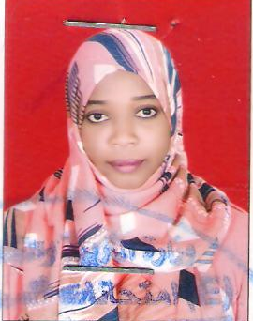 Israa Abbo Adam Mohamed

**[Esra.abbo@gmail.com](mailto:Esra.abbo@gmail.com)**

**PERSONAL STATEMENT**

|  |
| --- |
| house number :236  Khartoum Sudan |
| 00249998385983. 00249114619458 |
|  |
| [Esra.abbo@gmail.com](mailto:Esra.abbo@gmail.com)  [Esra-almahy@hotmail.com](mailto:Esra-almahy@hotmail.com) |
|  |
| **Sex**: female. | **Date of birth** 21/9/1989. | **Nationality** :Sudanese |

WORK EXPERIENCE

Job Title: **research Assistant**

Dates of Employment:  **(February /2017-current)**

Organization Name**: University of Khartoum**

**Faculty of Medical**

**laboratory**

**Location:** Sudan – soba

Job Title: **Teaching Assistant**

Dates of Employment:  **(December /2013- may /2016)**

Organization Name**: University of Bahri**

**Location:** Sudan – Bahri

##### Job Title: **Research assistant**

##### Dates of Employment: **(October 2012- November 2013)**

Organization Name**: Ministry of science and**

**Technology) molecular biology,**

Microbiology laboratory)

**Location:** Sudan –Khartoum

**EDUCATION**

|  |  |
| --- | --- |
| September 2008 -June 2012: | Bachelor in Science and technology Botany ( Excellent) |
| November 2014-june 2015:    April 2016 – current:    July, 14,2011 to July 21,2011 | Omdurman Islamic university    MS.c Qualifying  Khartoum university  Faculty of Science (Botany )  MS.c student (Genetics & Molecular Biology )  Khartoum university    Trainee in National Center For Research Commission of Biotechnology and Genetics Engineering. |

Language : Arabic ,English