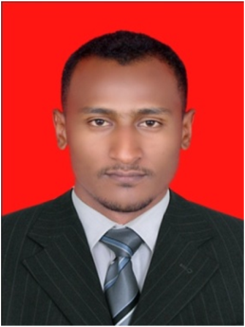 **Musa ALtahir Mohammed Ali**

One street 24 station ⚫ Khartoum ⚫ Phone: +249917962794 ⚫ [musa_altahir@yahoo.com](mailto:musa_altahir@yahoo.com)

**English Communication Teacher**

* 28 months of teaching experience in three different institutions.
* Respected leader of creative teams, who effectively reinforce and build advance communication skills.
* Expert in the technical, conceptual and content development of English language and advanced communication skills teaching. Proven ability to drive record-high in teaching English skills.

**Skills**

|  |  |
| --- | --- |
| * Corporate Communications * Creative Team Leadership * Web & Print Content Development * Training of trainers (TOT) | * Development of Training Materials * Public & Media Relations * Art and poetry writing * Teaching Knowledge Test Course (TKT) |

**Professional Experience**

**ECC (**English Cultural Centre**)** English language teacher for communication skills for fresh learners and advanced English seekers. 15/3/2014 to 15/12/2014

**EDC (**English Discussion Centre**)** English language tutor for advance communication skills. 1/1/2015 to the present day

**Razo Centre** for training, English language teacher for earlier learners and fresh student. 1/4/2016 to the present day

**Presidency of Khartoum Police Force – Engineering department,** Sanitation Engineer, site engineer for the whale facilities of the police force. 1/1/2013 to 31/10/2013  
  
***Selected Accomplishments:***

* Developed and launched integrated personal experience of team work.
* Finding many ways for developing skills of others no matter how, no matter who, no matter where.
* Participation in many different social programs and poetry shows as well as charity associations.
* Guided many groups to the proficiency of English language four skills.
* IELTS score of 6.5.

**Musa ALtahir Mohammed Ali Phone: +249917962794**

**Technology**

|  |  |
| --- | --- |
| **Software:** | MS Office (Word, Access, Excel, PowerPoint) |
| **Web:** | Web Server Administration and Internet, |

**Education**

**National Ribat university / callage of languages and translation/ khartoum**

**High Diploma of English Language  
Omdurman Islamic University/ UNESCO Chaire in water resources, Khartoum**

**Master of Science, Environmental Engineering 5/2016**

**Sudan University of science and technology**

**Bachelor of Science, 9/2012**

* Major: Engineering
* Minor: Water resources and Environmental studies
* Graduated with honor degree

**Ongoing studies**

**National Ribat University**

**English Language Department**

* Major: English Language
* Minor: Linguistic

**References:**

**Mustafa Eisa Adam**

249918900632+

**Email: mustafaeisa44@yahoo.com**