C.V

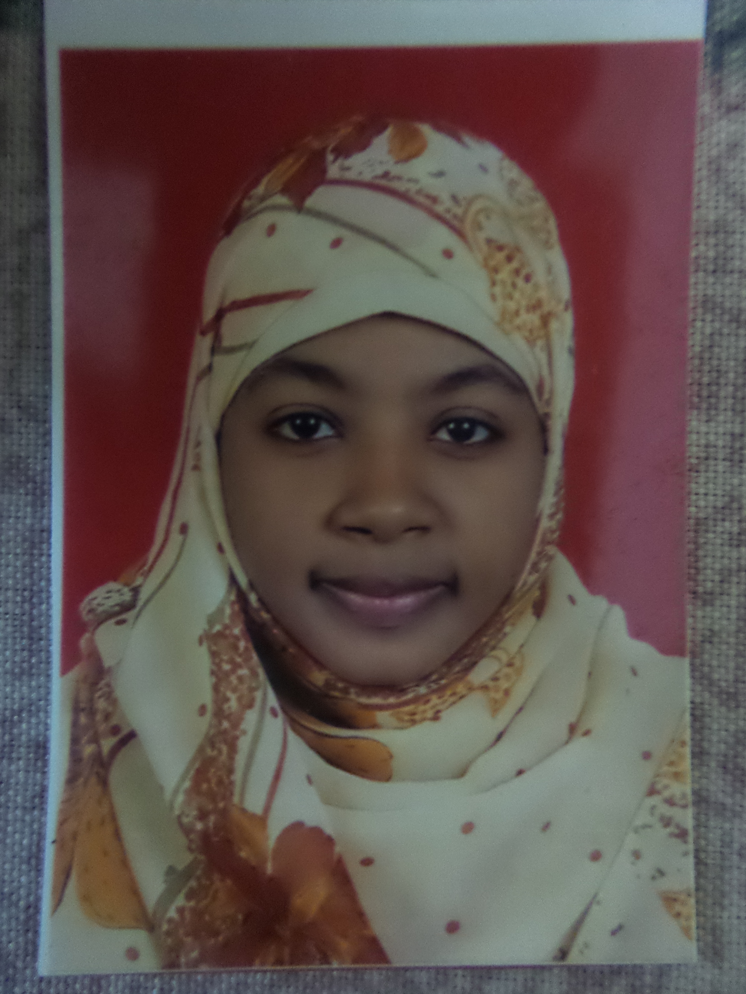

Nihal Isam Eldeen Mohammed

H.No.445 , Juba turn , Arkawet , Khartom, Nile East

00249997373397

Nany.ziada@gmail.com

Objective:

My aim is to use the knowledge I got to help improving my country.
I believe that knowledge is the right way to accomplish success in life.
I look forward to improve my skills as well as I can.

Education:

Qualification | Board | University\College | Specialisation | Year | Marks
Degree Of Bachelor | Honours | University of Khartoum | Zoology | 2015 | First Class
 | Full Time | Collage  of Science | Parasitology

Personal Information:
Name: Nihal.

Father Name: Isam Eldeen.

DOB: 18/11/1991

Marital Status: Single.

Hobbies: Writing, Reading.

Languages: Arabic and English.

Experiences and Skills:
- Molecular Biology Lab in “The National Center of Researches”.
- Training of Entomology, Environment, and Helminthes Parasites labs in Khartoum University.
- Course of water and food quality accuracy at Midical Military Hospital .
- Immunological tests in “The Central Lab” (National Serves).
- Public Speaking Skills “HR Development”.
- Self Management “HR Development” .

NIHAL ISAM ELDEEN MOHAMMED
THANX

