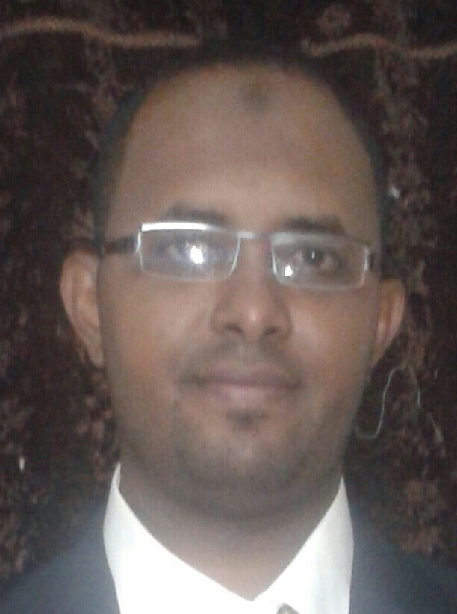
Mohammed Hassan Alnazeer
Budaidah,
Kingdom of Saudia Arabia
Mobile phone: +966 502622435
E- mails: mhmd_nazir83@yahoo.com

Personal data:

- Date & place of birth: 3 February 1983 – Riyadh / K S A.
- Nationality: Sudanese
- Gender: Male
- Marital status: Married and I have three Kids
- Religion: Islam

Qualifications:

- B.pharm (Honors) - 2006 (second class - division one) - University of Khartoum.
- M.pharm (clinical Pharmacy) – 2013 - University of Khartoum.
- Board Certified Pharmacotherapy Specialist (BCPS) - (December 2012) – BPS – USA.
- Clinical pharmacy specialist – Sudan Medical Council - Apr 2014.

Professional experience:

- I worked as a Teaching assistant at the University of Khartoum (Sudan), faculty of pharmacy - Department of pharmacology (September 2008 until Dec 2013). In this position I was assuming the following:
  - Dealing with the different techniques of the pharmacological experiments especially those are done at the isolated tissues.
  - Reviewing the clinical and community pharmacy cases for students.
  - Presenting tutorials for students.
  - Assuming different non-academic and administrative duties at the department.

- I worked as a lecturer in the University of Khartoum (Sudan), faculty of pharmacy - Department of pharmacology (Jan 2014 till Sep 2015). In this position, I assumed the following:
- I taught Pharmacology lectures for undergraduate pharmacy students.
- I worked as a clerkship’s preceptor for postgraduate clinical Pharmacy students

- Now, I work as a lecturer in Qassim university (KSA) – College of pharmacy – Department of pharmacy practice (Sep 2015 till now).

- I am heading the e-learning unit - Qassim university (KSA) – College of pharmacy (Oct 2015 till now).

- I had several courses and workshops in the field of e-learning.

- I am supervising PharmD internship students in Buraidah central hospital.

- I practiced Clinical Pharmacy at Soba Teaching Hospital as a part of my Master degree program. (April 2012 – September 2012).

- I worked in a part-time position as a clinical pharmacist in the ICU of the international hospital in Khartoum (Sudan). (May 2014 till Sep 2015).

- I have a Review Paper not published yet, titled (P-glycoprotein inhibitors: Efficacy in reversing multi-drug resistance for cancer chemotherapy).

- I am a Board Certified Pharmacotherapy Specialist (BCPS) accredited from the Board of pharmacy specialty (BPS) in USA - (December 2012).

- I worked as an instructor in accredited training center (Top Team Center), teaching and orienting the pharmacists those are willing to be prepared for the pharmacotherapy specialty exam (Board of Pharmacy Specialty). (Jan 2013 till Sep 2015).

- I worked as a scientific office trainer and presenter of the Blue Nile Pharmaceutical Factory, (April 2013 till Sep 2015).

Academic interests:

- Pharmacotherapy and Clinical Pharmacy courses.
- Pharmacology courses.
- Biostatistics and study designs courses.
- Basic and Clinical Pharmacokinetics courses.
- Community pharmacy practice and communication skills courses.

Certificates awarded:

- Certificate of specialty from the Board of pharmacy specialty (BPS) in USA - Board certified pharmacotherapy specialist (BCPS) – (December 2012).

- Certificate of clinical Pharmacy specialist – Sudan Medical Council - Apr 2014.

- Certificate of training from the Advanced training & performance development center - University of Khartoum, upon having a training course in (Basics of Scientific Research) (Aug 2010).

- Certificate of training from the Advanced training & performance development center - University of Khartoum, upon having a training course in (System and Methods of University Teaching) (Aug 2010).

- Certificate of training from the National College for Medical and Technical studies centre for Professional Development, upon having a training course in (Using Hinari & Pubmed in scientific search) (February 2011).

- Certificate of experience and good standing as a lecturer (instructor) from Top Team center, upon teaching the preparatory course of pharmacotherapy updates for pharmacists intending to have BPS certification and re-certification.

- Certificate of training from BUILDERs CENTER upon having a training course in
TIME MANAGEMENT (January 2008).

- Certificate of training course from training & communication centre upon studying some computer courses (July 2001).

- Certificate of appreciation upon the contribution in organizing the 1st international exhibition of medicinal products. (Khartoum, December 2005).

- Certificate of attendance & participation in the 2nd annual congress of the APSF (Khartoum, October 2003).

- Certificate of attendance the 25th scientific conference of the Arab pharmacist union (Khartoum, December 2005).

Computer skills:

- Ms windows, Word, Excel, and Power-point.
- Internet browsing & E-mail usage.
- Arabic / English typing.

Languages:

- English, fluent.
- Arabic, mother tongue.

References:

Dr. Bashier Ibrahim Osman - Associate professor in Molecular Pharmacology
Dean Faculty of Pharmacy – University of Khartoum
Mobile: 00249 115597222 - 00249 918384627

Dr. Abubakr Osman Mohamed Nur - Associate professor in pharmaceutics
University of Khartoum - Faculty of Pharmacy
Mobile: 00249 915222390

Dr. Ahmed Ibrahim Fathel Rahman – Assistant professor in clinical toxicology
Qassim University- College of Pharmacy
Mobile: 00966 547754981

