**Curriculum Vitae**

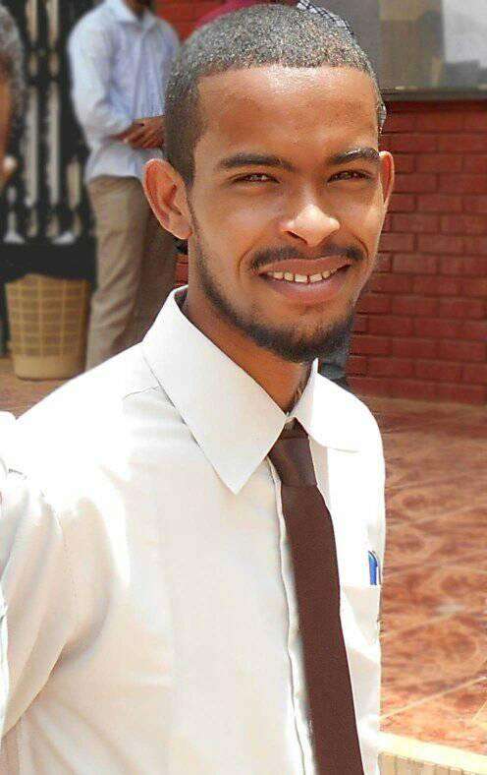

**ABOUT ME:**

**SINCE from I was undergraduate student, I decided to improve my teaching and instructioning ability by doing seminars and related activities. this because teaching and interactive learning are my passion. Also doing research and involvement of student in such way of critical thinking are my wishes.**

**Whenever I searched a teaching or researching opportunities I preferred the biochemistry & pharmacology teaching since I decided to be a biochemist and I am in the way to do that. I never minded to teach pharmacology also; because the strong interrelationships between pharmacology and biochemistry. I hope to go further and further in teaching and research ability to help my students and myself to be a teacher of value if Allah wish.**

**Personal details:**

**Name: Tarig Omer Ahmed Albashir**

**Nationality**: Sudanese.

**DATE OF Birth**: 1/1/1993

**Gender**: Male.

**Religion**: Muslim.

**Residence**: Khartoum.

**Marital Status**: Single.

**Contact address**: Sudan-Khartoum-omdurman- omudda -block No 4- house No 123.

**Mobile No:** 0922200736 / 0124816606

**E-mail**: [tarig12omer@gmail.com](mailto:tarig12omer@gmail.com) and [tarig1775@yahoo.com](mailto:tarig1775@yahoo.com)

**Academic Credentials**

* **Primary school**: Abobkr Alsidig Basic Level School.
* **Secondary school**: Ombada Alnmozgia / King Fahad Secondary High Level School.
* **Qualifications:**
* **University**: Bachelor of pharmacy (B. Pharm. **Honors**) Grade (**second class division** **one)** Omdurman Islamic University.
* **Graduation** year:2016
* **Current** study: **MSc biochemistry – faculty of medicine -U of K**

**Language:**

* Arabic: mother tongue
* English: good

**Achievements**:

* Batch 15 academic prize march 2014
* Pharmacology prize of academic Excellence October 2015
* best member at pharmacology department for April 2017

**Work Experiences**

* Omdurman Islamic University- Faculty of pharmacy- Department of pharmacology- attached for training

From January2017-up to date

* tutoring in karrary university faculty of pharmacy Department of pharmacology

From February2017- up to date

**Skills:**

* **M S Office**
  + **Presentation programs:**
* (PowerPoint, Prezi, Preshow producer, Camtasia ...)
* -Photoshop
  + **Production** and broadcasting of video lectures (in biochemistry &pharmacology)

**Participations**

**1-The 18th Congress of the Scientific Association of the Pharmacy Colleges in the Arab World- The 1st International conference of the faculty of Pharmacy –Omdurman Islamic University.(leader of learning & teaching section of undergraduate students participation in the conference)**

**Publications:**

* 1-Current paper writing: 16sRNA based molecular identification of MRSA in addition to phonotypical & genotypical determination of Antibiotic resistance

**Referee:**

when needed