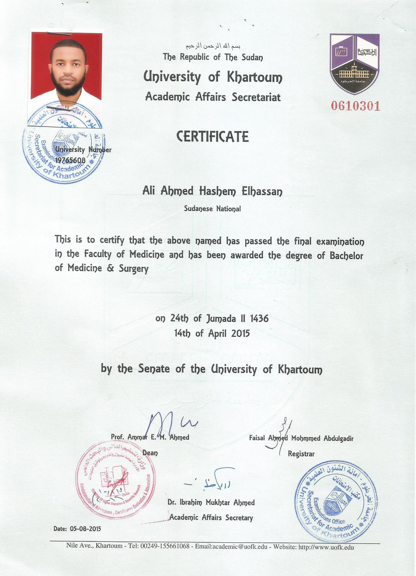

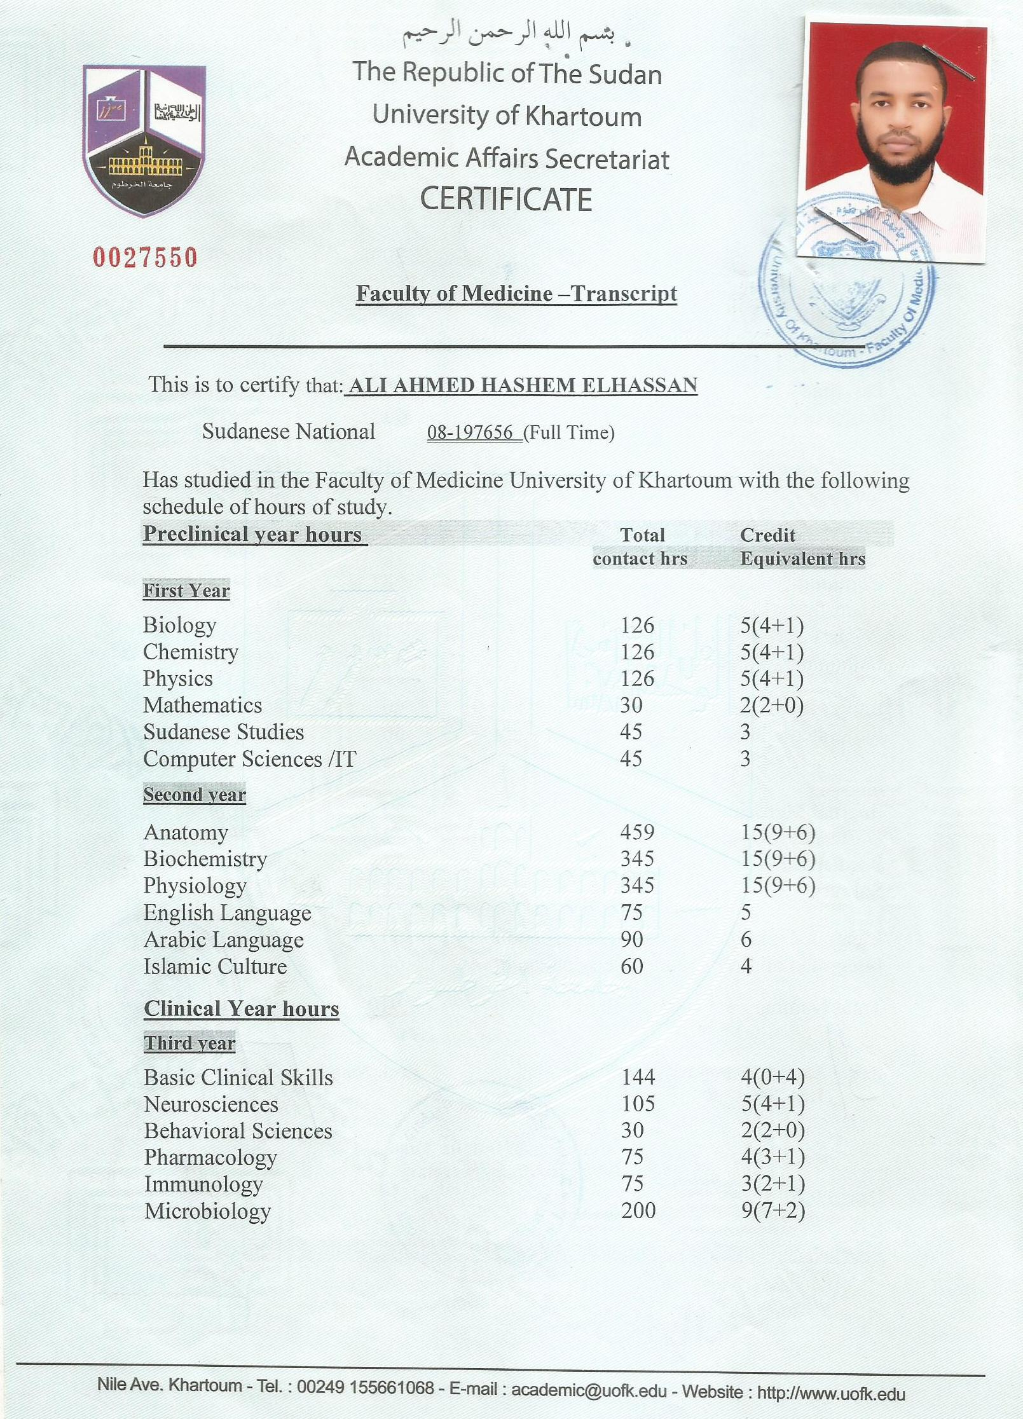

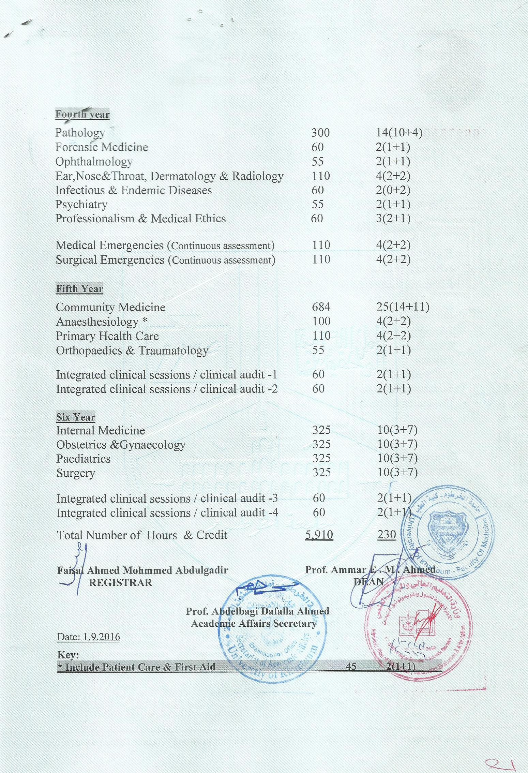

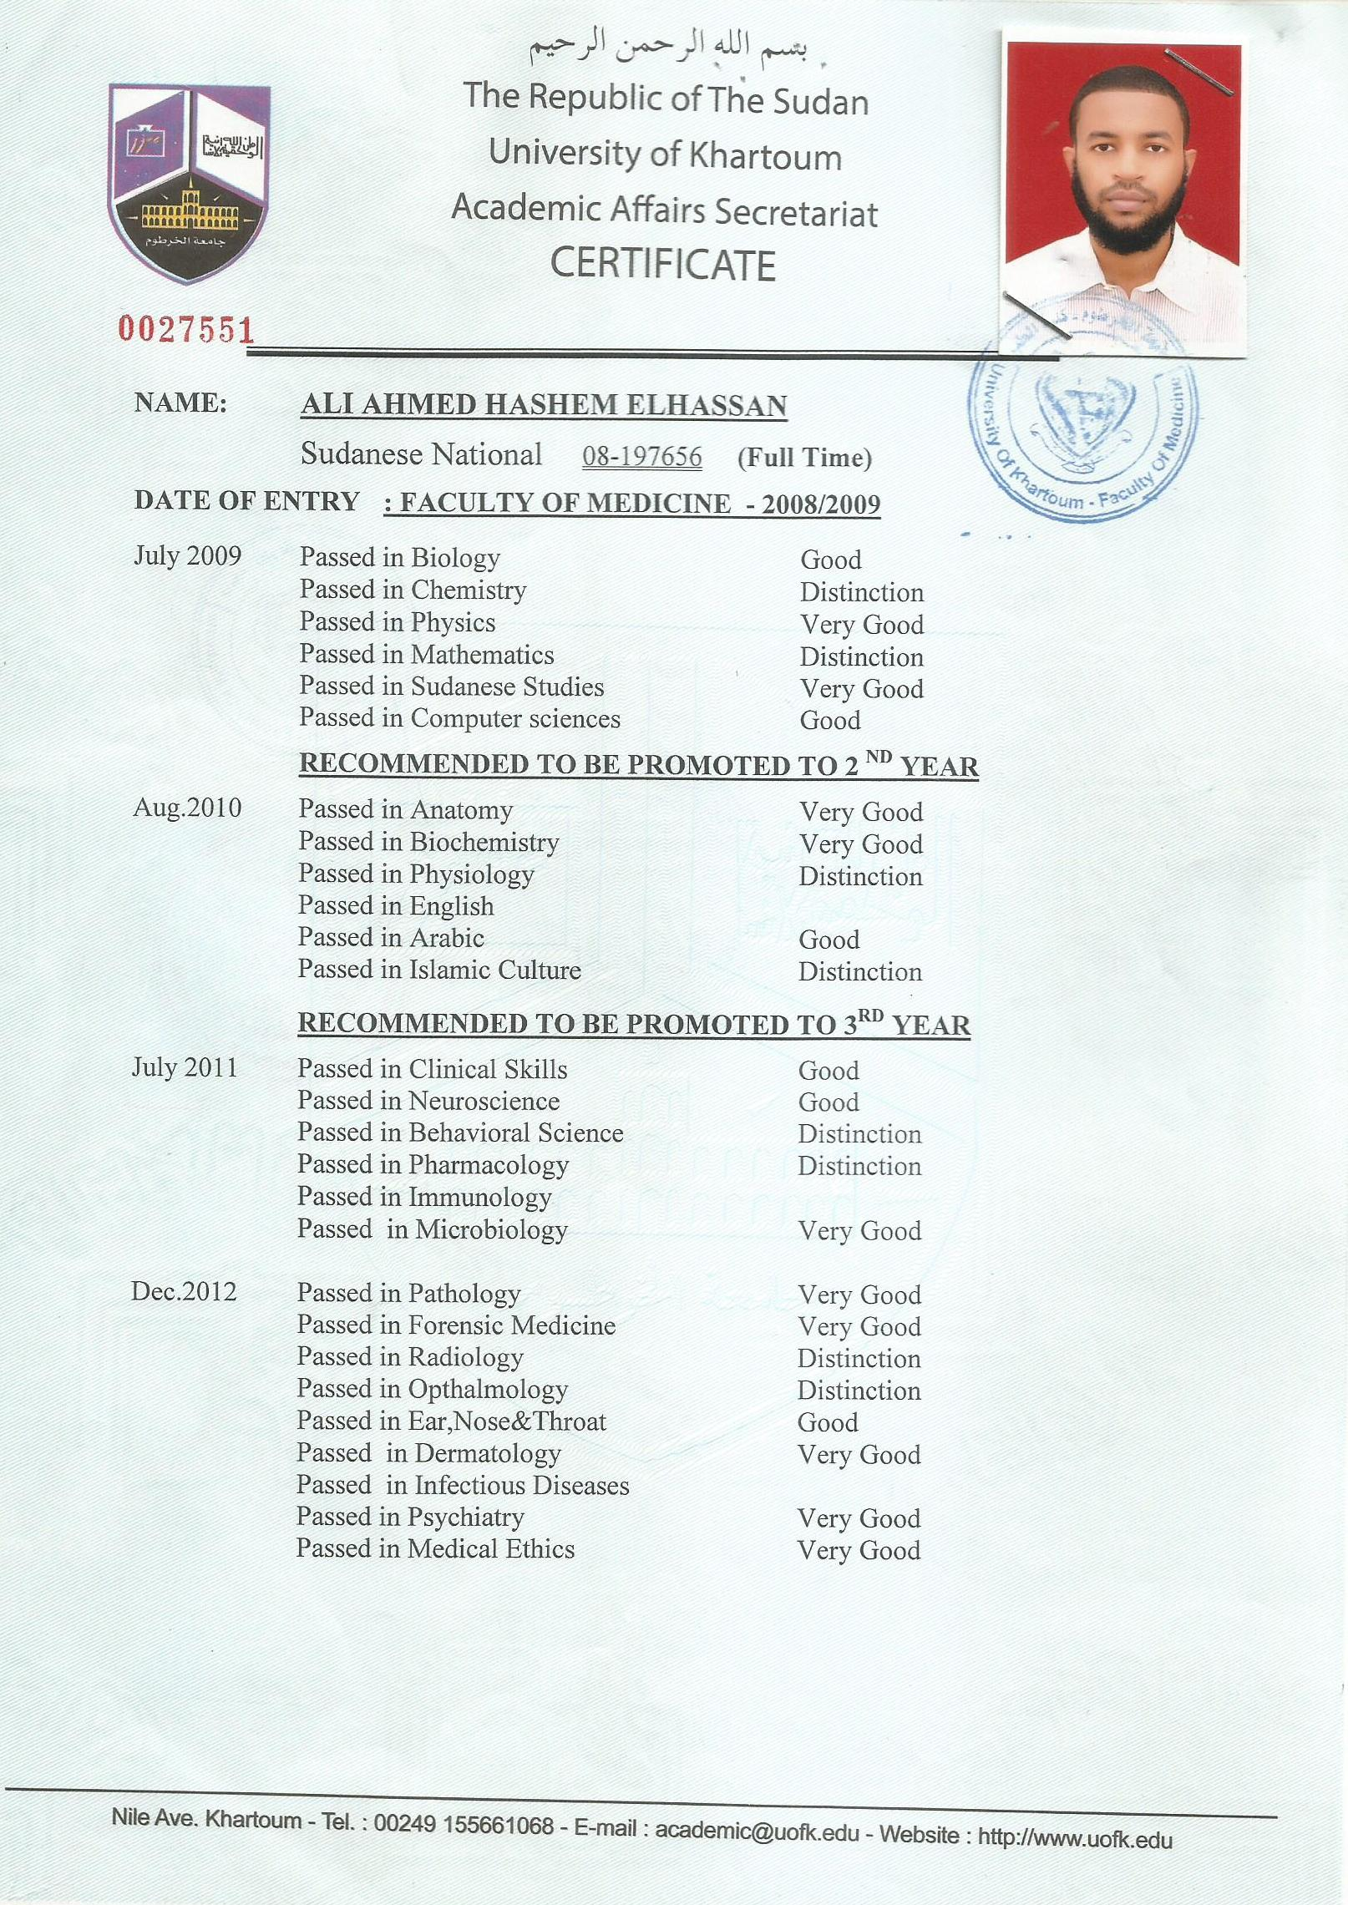

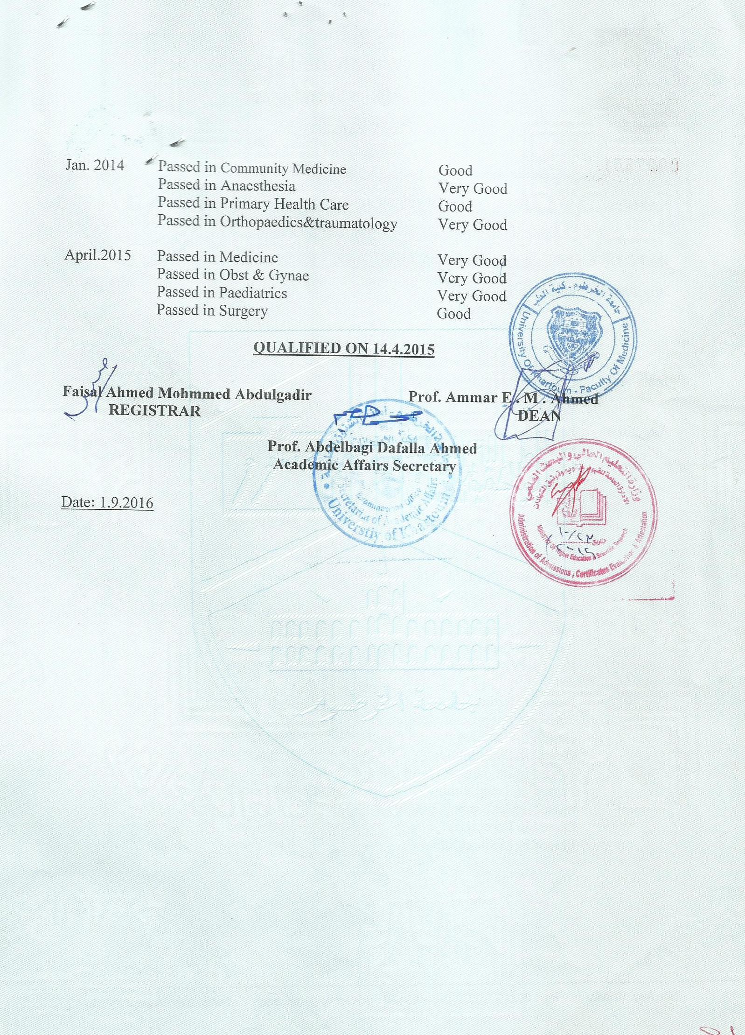

**Ali Elhassan**

|  |
| --- |
| **Personal contact** |
| Gabra, Elhawa Street,Khartoum, Sudan. |
|  |
| Tell:(249)15877216 |
|  |
| Email: ali.alhassan1990@gmail.com |

**Education**

|  |  |
| --- | --- |
| **Faculty of Medicine, University of Khartoum, Sudan. Bachelor of Medicine & Surgery "MBBS". Six years.** | **2008-2015** |
| **Ministry of Health, Sudan. Internship.**  **Started Msc in human physiology**  **University of Khartoum** | **2015-2017**  **2017-** |

**Research Experience**

|  |  |
| --- | --- |
| **Ali Elhassan, et al. mini survey about the knowledge, attitude, and practice of mothers towards diarrheal diseases at duka province.**duka, Gadaref, Sudan. | **April**  **2013** |
| **Ali Elhassan, et al. mini survey about the knowledge, attitude, and practice of the people at duka province about HIV/AIDS.**duka, Gadaref, Sudan. | **April**  **2013** |
| **Ali Elhassan, Assma Abdelaal, PHD. The effects of father absence among secondary school students in Khartoum locality** | **September**  **2013** |

**Work Experience**

|  |  |
| --- | --- |
| **November 2015-January 2016** | **Paediatric shift of internship.**Turky Hospital, Khartoum, Sudan. |
| **February 2016-April 2016** | **Medicine shift of internship.** Haj Elsafi Hospital, Khartoum, Sudan. |
| **May 2016- August 2016** | **Obstetrics and gynecology shift of internship.** Elseeni Hospital, Khartoum, Sudan. |
| **October 2016- January 2017** | **Surgery shift of internship.** Ibrahim Malik Hospital, Khartoum, Sudan. |

**Seminars & presentations**

|  |  |
| --- | --- |
|  |  |
| **Ali Elhassan et al. Congestive heart failure.**Medicine Department, Faculty of Medicine, University of Khartoum. | **February**  **2013** |
|  |  |
|  |  |
| **Ali Elhassan, et al. Acute abdomen.** SurgeryDepartment, Faculty of Medicine, University of Khartoum. | **February**  **2015** |
|  |  |
|  |  |

**Conferences and Courses**

|  |  |
| --- | --- |
| **The First International Cardiology Conference.**Friendship Hall, Khartoum, Sudan. | **January**  **2014** |
|  |  |
|  |  |
| **The 7th Scientific Conference of the Sudanese Chest Physicians Society.**CPD, Khartoum, Sudan. | **March**  **2013** |
|  |  |
| **The 39th International Scientific Conference of the Sudan Association of Surgeons.**Friendship Hall, Khartoum, Sudan. | **March**  **2013** |
|  |  |
| **Research Methodology workshop,** CPD, Khartoum, Sudan | **2013** |
|  |  |
|  |  |
| **The First International Hypertension Conference of the Sudanese Society of Hypertension.**Friendship Hall, Khartoum, Sudan. | **December**  **2013** |
|  |  |
| **Medical Neuroscience online course.**  A 12 week online non-credit course authorized by Duke University and offered throughCoursera. | **January**  **2014** |
|  |  |
| **The 27th Scientific Conference of Sudan Association of Physicians.**Friendship Hall, Khartoum, Sudan. | **February**  **2014** |
|  |  |
| **Symposium on update in medicine.**University of Khartoum, Khartoum, Sudan. | **December**  **2014** |
| **The European Resuscitation BLS/AED Provider Course.**  University of Khartoum, Khartoum, Sudan. | **February**  **2015** |
| **Approach to critically ill patient workshop.** Emergency Medicine Council, Sudan Specialization Board, Khartoum, Sudan. | **April**  **2015** |
| **Emergency medicine Conference.**  Emergency Medicine Council, Sudan Specialization Board, Khartoum, Sudan. | **April**  **2015** |
| **Teaching and learning workshop, EDC, Faculty of Medicine, U of K.** | **December 2016** |
|  | **January 2017** |
| **Technology assisted medical research workshop, EDC, Faculty of Medicine, U of K.** |  |

Language Skills

1- Arabic: Mother tongue

2- English: Very good.

Volunteer and Community Services

|  |  |
| --- | --- |
|  |  |
|  |  |
| **Worked with a team form Faculty of Medicine, University of Khartoum in doing surveys and solve some of the sanitation problems for people affected by Sharg Elneel floods.** | **November**  **2013** |
|  |  |

Professional Membership

|  |  |
| --- | --- |
|  |  |
|  |  |
|  |  |
| **Member of the Sudanese neurogenetics research group.** | **2017-** |