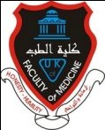
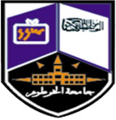


Name: Rasha Yahya Hassan Hamid
Date of birth: 18/6/1992
Address: khartom bahri
Email: RYHHBS@Gmail.com
Tel: 0915181532

Education & Qualifications:
Qualification | Date achieved
MBBS University of alneelain | June 2015
BLS, ALS instructor | December 2016
Professionalism at alneelain university | 2014
First aid course at UNISCO training centre | 2013
Work Experience:
Current Wor: Khartoum hospital
Job Title: house officer
Employer: HO
Specialty:surgury

Training Courses Attended:
Course Title | Providing Body/ Place | Duration | Date Obtained
Immediate life support (ILS) | CPD/alneelain university | 1 DAY | 2014
Trauma life support | CPD/ alneelain university | 1 day | 2014
Pediatrics life support | CPD/ alneelain university | 1 day | 2014
Advance life support | Alkhartoum university | 2 days | August 2015

