Curriculum Vitae

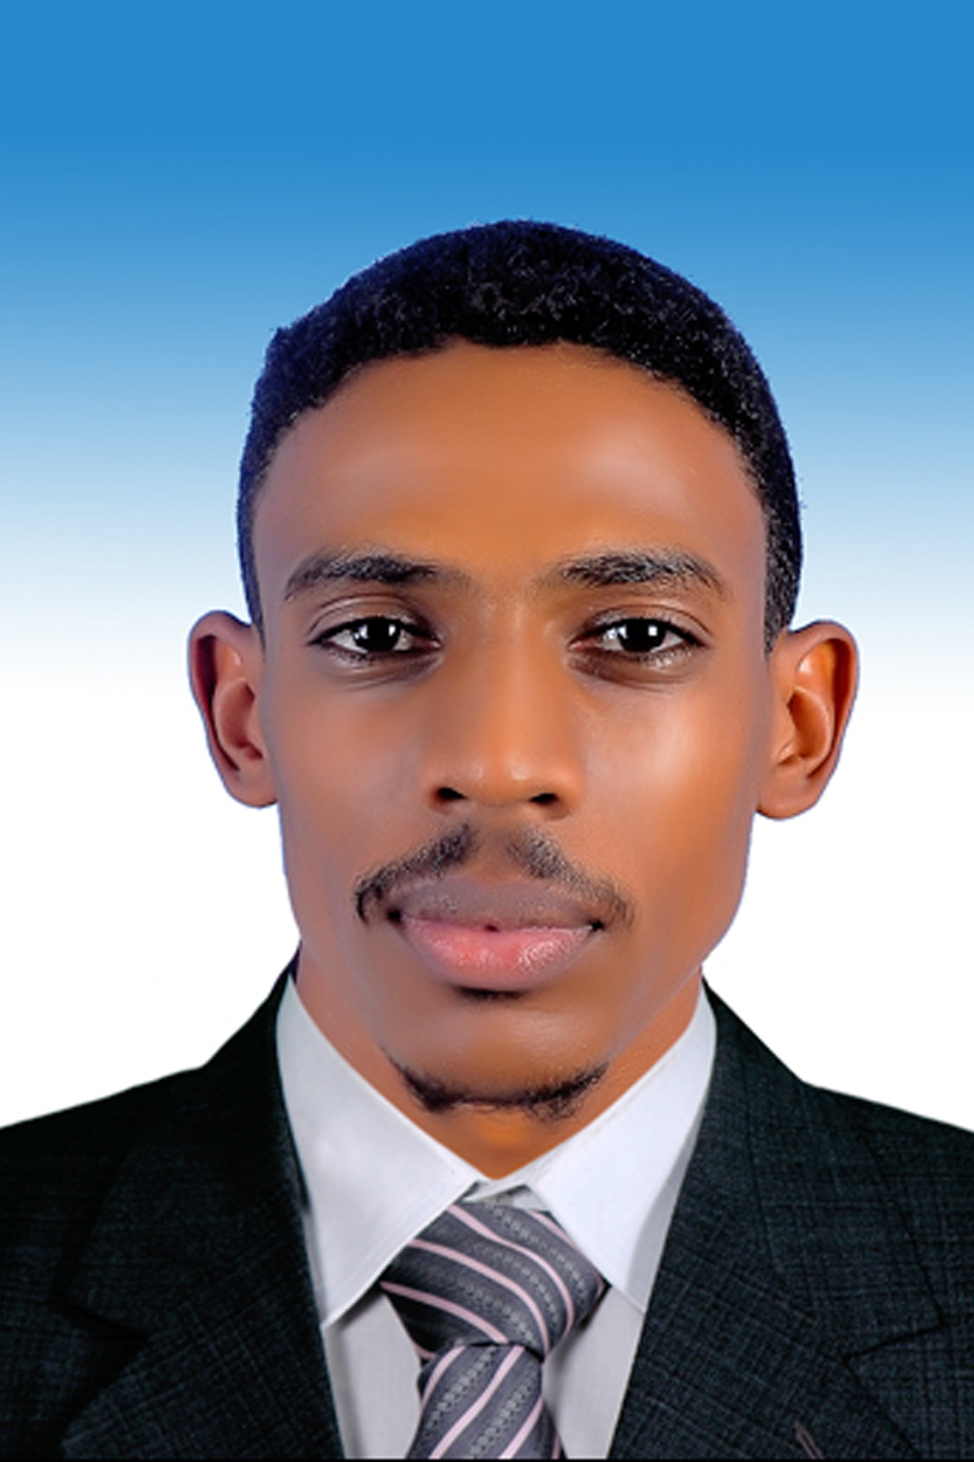

Personal Data:

**Name**: Mutaz Ahmed Elsir Fadlalla. **Title:** Teaching Assistant.

**Birth**: February, 11, 1992. (Najran, KSA).

**Gender:** Male. **Citizenship:** Sudanese.

**Marital status:** Single.

**Phone:** (+249)110113890 / (+249)926028272.

**E-mail:** [Mutaz.elsir83@gmail.com](mailto:Mutaz.elsir83@gmail.com)

Academic Qualifications:

|  |  |  |
| --- | --- | --- |
| **Month-Year** | **Degree** | **Institute/Department** |
| December 2014 | BSc of Medical Laboratory Sciences (Microbiology) | Al Neelain University |
| July2017 *(current) | MSc of Medical Laboratory Sciences (Microbiology) | Al Neelain University |

Academic Experience:

|  |  |  |
| --- | --- | --- |
| **Month – year** | **Description** | **Location** |
| March 2016- current | Teaching assistant | Al Neelain University, Faculty of Medical laboratory Sciences, Department of Medical Microbiology. |

*Other academic experiences:*

* Practical Virology course for Nile Collage (at Al Neelain University), third year, June – July 2016.
* Practical Virology course for National Uneversity (at Al Neelain University), Fourth year, February-2017.

Professional experiences:

As a Microbiology and laboratory technologist at:

* Dermatology and Venereal Diseases Hospital, Khartoum teaching hospital (December 2014 - April 2015).
* Multicare medical lab (January 2016- current).
* Al-injaz Hospital (January 2016 – July 2016).
* Aliaa specialized Hospital (April 2017 – June 2017).

Participation in Symposiums/ Conferences:

|  |  |  |
| --- | --- | --- |
| **Month-Year** | **Description** | **Country** |
| June-2015 | The 1st  Microbiology Symposium of al Neelain University, Faculty of Medical Laboratories Scinces. | Khartoum – Sudan. |
| Dec-2015 | The 4th Conference of Sudanese Society of Clinical Biology (SSCB. The 14th Conference of Arab Federation of Clinical Biology (AFCB), In Collaboration with the International Federation of Clinical Chemistry and Laboratory Medicine. | Khartoum – Sudan. |

Manuscript accepted for publication:

* Evaluation of immune response to Hepatitis B vaccine in Laboratory workers, Khartoum State, Sudan.
* Molecular Detection of Carpabenem Resistant genes among Different Gram Negative Isolates, Khartoum State, Sudan.

Ongoing Research:

* Genetic variability of E6 and E7 genes of Human Papilloma Virus type 16 & 18 among Sudanese women.
* Development of loop mediated isothermal amplification for the detection of carpabenem resistant genes among different gram negative isolates.

References:

* ***Dr. Khalid A Enan:***

Central Laboratory, Ministry of High Education and Scientific Research, Khartoum, Sudan.

Phone: (+249912651103).

Email: [Khalid.enan@gmail.com](mailto:Khalid.enan@gmail.com)

* ***Dr. Ibrahim Khider Ibrahim.***

Head of Haematology department, Al Neelain University, Faculty of Medical laboratory Sciences

Mobile: +249912967782

E- mail: [Ibrahimkh82@gmail.com](mailto:Ibrahimkh82@gmail.com)

**July 2017**

