E- Mail Gehan_hegazy@yahoo.com

Gehan Hegazy Hegazy

Professor of pharmaceutical and medicinal chemistry
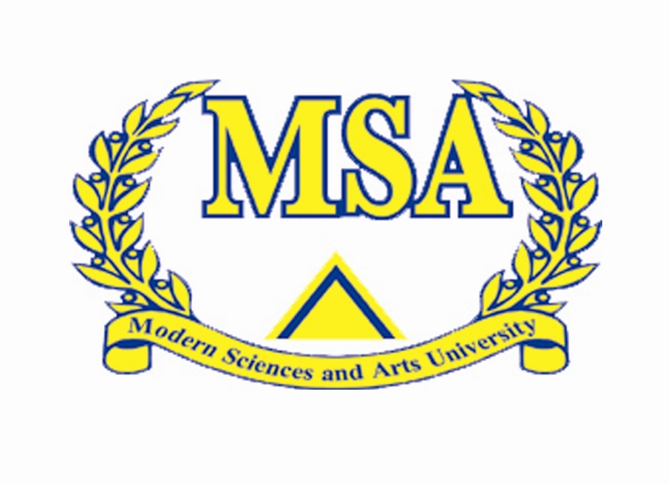
Cairo University

Curriculum Vitae @ 2017

Gehan Hegazy Hegazy
professor of Pharmaceutical Chemistry
Education | Doctorate of Philosophy (Ph.D.) in medicinal chemistry  Cairo University (one of the top 550 university in the world according to Shanghai ranking and faculty of pharmacy is one of the best 200 faculty according to ranking)  Cairo ,Egypt.  2000  Master of Pharmaceutical medicinal Chemistry  Cairo University  Cairo ,Egypt.  1997  Bachelor of Pharmacy  Cairo University Excellent with honor degree.  Cairo ,Egypt.  1990
Experience  And job careers | Dean of faculty of pharmacy in university of medical science and technology Khartoum Sudan From january 2016- till January 2017.  -Professor of pharmaceutical medicinal chemistry in Cairo university (may 2015- till now)  -Associate professor of pharmaceutical organic chemistry in King Saud university 2008-2013.( one of the best 300 universiy in the world according to shanghai ranking)  -Associate professor of pharmaceutical organic chemistry in October university for modern sciences and arts(MSA). 2007-2008.  -Associate Professor in Pharmaceutical Chemistry Department Cairo University (2006 till may 2015)  - Assistant professor of pharmaceutical organic chemistry in Miser Intenational University (MIU) 2004-2007.  -Assistant professor in Pharmaceutical medicinal Chemistry Department Cairo University (2000-2004)  -Assistant lecturer in Pharmaceutical medicinal Chemistry Department Cairo University (1997-2000)  -Demonestrator in Pharmaceutical medicinal Chemistry Department Cairo University (1990-1997)
Professional Career Experience  In Cairo university,MSA , MIU and King Saud university  Professional Career Experience  (Cont.) | October University For Modern Sciences & Arts (MSA)  Faculty of Pharmacy Experinces.  Teaching and assisting in the delivery of academic education courses for undergraduates, the courses include:  - Pharmaceutical Chemistry 1 (PC331)  - Pharmaceutical Chemistry 2 (PC 431)  In addition, I’m involved in several administrative, academic, and cultural activities in the University, include:  - Pharmaceutical Chemistry 1 (PC331) Miser International University (MIU).  - Pharmaceutical Chemistry 2 (PC432) Miser International University (MIU).  - Drug Design. (PC 433). Miser International Unevirsity (MIU).  - Pharmaceutical Chemistry for third year student ( Cairo University).  - Pharmaceutical Chemistry for fourth year student ( Cairo University).  - Courses for post graduates in Pharmaceutical Chemistry Cairo University.  - Courses for undergraduate PC 471 and PC 313, Courses for postgraduate PC 511, 535,591,592 and PC 512 in Kingsaud university.  Main Responsibilities include:  - Dean of the faculty of pharmacy in university of modern science and technology (Sudan) (January 2016 till January 2017)  - Supervision of master and PH.D students both in Cairo University , in Misr International University ,MSA (Modern Science And Arts University) and in King Saud university  - Supervision of PH.D students in university of modern science and technology (Sudan)  - Head of Pharmaceutical chemistry department in Modern Science and Arts (MSA) university.(2007-2008).  - Responsible for the Pharmaceutical Chemistry Department In Miser International University (MIU) from2004 till 2007.  - Improvement of Pharmaceutical Chemistry Courses and courses specifications in Miser International University (MIU) (2004-2007).  - Course coordinator for pharmaceutical Chemistry 1 , for pharmaceutical Chemistry 2 and Drug Design in Miser International University (MIU) (2004-2007)  - Course coordinator for pharmaceutical Chemistry 1 , for pharmaceutical Chemistry 2 and Drug Design in Miser International University (MIU) (2004-2007)  - Supervision on many master and Ph.D students in Cairo university,King Saud university,MSA university ,and MIU university.
Ph.D. Study | Synthesis of some acridine derivatives with expected anti-tumor activity and topoisomerase inhibition
MBA Study | Synthesis of some acridine derivatives with expected anti-tumor activity
Published Papers | 1-Design, synthesis and SAR of new-di-substituted pyridopyrimidines as ATP-competitive dual PI3Ka/mTOR inhibitors; Aisha A.K. Al-Ashmawy , Fatma A. Ragab , Khaled M. Elokely , Manal M. Anwar , Oscar Perez-Leal ,Mario C. Rico , John Gordon , Eugeney Bichenkov , George Mateo , Emad M.M. Kassem ,Gehan H. Hegazy , Magid Abou-Gharbia , Wayne Childers , Bioorganic & Medicinal Chemistry Letters 27,3117-3122,(2017).  2-Design and synthesis of quinazoline derivatives : biological evaluation for their anticancer and VEGFR inhibitory activities. Wegdan M. Gehan H. Hegazy, Sameh E. Dalal A. , Life Sience journal 13,57-68, (2016).  3- Synthesis, Anticonvulsant Activity and Molecular Modeling Study of Some New Hydrazinecarbothioamide, Benzenesulfonohydrazide, and Phenacylacetohydrazide Analogues of 4(3H)-quinazolinone.  Huda S. A. Al-Salem, Gehan H. Hegazy, Kamal E. H. El-Taher, Shahenda M. El-Messery, Abdulrahman M. Al-Obaid, Hussein I. El-Subbaghe. Bioorganic & Medicinal Chemistry Letters 25.(2015).  4. Huda S. A. Al-Salem, Hussein I. El-Subbagh, Kamal E. H. El-Taher, Gehan H. Hegazy, Abdulrahman M. Al-Obaid. Quinazolinone analogues for use as anticonvulsant agents. European  Patent, EP 2 740 727 A1, June (2014).  5- Synthesis, Docking and Biological Activities of Novel Hybrids Celecoxib and Anthraquinone Analogs as Potent Cytotoxic Agents. Maha S. Almutairi , Gehan H. Hegazy , Mogedda E. Haiba , Hamed I. Ali,  Nagy M. Khalifa and Abd El-mohsen M. Soliman . International Journal of Molecular Sciences, 15, 22580-22603,(2014). doi:10.3390/ijms151222580  6- Synthesis and in vitro antiproliferative effect of novel quinoline based potential anticancer agents. Reem Arafa, Gehan H. Hegazy, Gary A. Piazza , Ashraf H. Abadi, European j. of Medicinal Chemistry 63,826-832, (2013) .  7-Synthesis of novel bis-anthraquinone derivatives and their biological evaluation as antitumor agents. GehanH. Hegazy, Azza Taher ,Archives of pharmacal research,36,573-578(2013)  8-Synthesis of new Ester Entities of NSAIDs with Nitric Oxide Releasing Properties .Gehan H. Hegazy ,Gehan M.Kamel. Life Science J. 9,1113-1120(.2012).  9- Design,synthesis,biological evaluation and comparative cox1 and cox 2 docking of p-substituted benzylideneamino phenyl esters of ibuprifenic and mefenamic acids. Gehan H. Hegazy, hamed Ali j. Bioorganic and medicinal chemistry. 20,1259-1270,(2012),.  10- Design and synthesis of acridine-4-carboxamide and acridine-4-carboxylate derivatives as tyrosine kinase inhibitors” Gehan H.Hegazy, Maha S. Almutari, Ebtehal s. Al-Abdullah” , life sience journals, 8,192-198(2011).  11- design, synthesis and docking studies of novel diarylpyrazoline and diarylisoxazoline derivatives of expected anti-inflammatory and analgesic activities, Gehan H.Hegazy, Ghaneya Sayed, Nahla Ahmed, Amal Yosef, life sience journals, 8,487-496(2011).  12- Computer aided design,synthesis and biological evaluation of novel acridine derivatives atopoisomerase I inhibitor . Gamil Mahmoud ElTaliawi, Enayat Ibrahim, Gehan H.Hegazy Nasser M. Ismail and Walaa Ramadan j. American Science,6,148, (2010).  13- Synthesis of 1H-indol-2,3-dione-3-thiosemicarbazone ribonucleosides as antibacterial agents. Shymaa E.Kassab, Gehan H. Hegazy, nahed M. Eid,Kamelia M.Amin, Adel A. Nucleosides, nucleotides and nucleic acids, 29,72, (2010).  14- Design and synthesis of novel benzopyran-2-one derivatives of expected antimicrobial activity through DNA gyrase B inhibition. G Hassan ,N Farag , Gehan H. Hegazy ,R.Arafa. Arch. Pharm Chem. 341, (2008).  15- Design and synthesis if some floctafenine derivatives of expected selective COX 2 inhibitor activity. Azza Taher, Gehan H. Hegazy. Bull.Fac. Pharm.Cairo Univ. ,45 (2), (2007).  16-Synthesis of furo-salicylanilides and their heterocyclic derivatives with anticipated molluscicidal activity, G. S. Hassan, Gehan. H. Hegazy and H. M. Safwat, Arch. Pharm. Chem. 339, 448-455, (2006).  17- Synthesis of some acridine derivatives of expected anticancer activity, H.M.Safwat, M.M. Hussien , N.M.Eid and Gehan.H.Hegazy, Al-Azhar Journal of Pharmaceutical Sciences, (2006).  18-Synthesis of novel -4-substituted -7-trifluoromethylquinoline derivatives with nitric oxide releasing properties and their evaluation as analgesic and anti-inflammatory agents, A. H. Abadi, Gehan. H. Hegazy and A. A. El-Zaher. Bioorg.Med.Chem. 13(20), 5759, (2005).  19-Synthesis of some floctafenine derivatives of expected anti-inflammatory / analgesic activity, Gehan.H.Hegazy, A. Taher and A. A. El-Zaher, Arch. Pharm., 338(8), 378 (2005).  20-Synthesis of some potential anti-estrogenic agents, H.M.Safwat, Gehan. H. Hegazy and G. S. Hassan, Bull. Pharm. Sci., Assiut University, 28, 27, (2005).  21-Synthesis of some glafenine derivatives of expected anti-inflammatory activity, Gehan. H. Hegazy and A. A. Elzaher, Bull. Fac. Pharm. CairoUniv., 41, 17, (2003).  22-Steroidal acridine derivatives of potential antitumor and aromatase inhibitory activities, Gehan. H. Hegazy, Alex. J. Pharm. Sci., 17(2), 145, (2003).  23- Synthesis of some steroidal derivatives of expected potential antitumor activity, H. M .Safwat , M .K .ElSaid ,S .R .Mohamed and Gehan .H .Hegazy , Bull.Fac.Pharm.Cairo Univ.,37,21,(1999).
Attended Training Courses | Work- shop attended:  1-Solving problems and make a decision. (Cairo university)  2- Quality assurance (Cairo university)  3-Talents of effective presentation. (Cairo university)  4-Academic talents (Cairo university)  5-Work shop in drug design using software programs in Assuit university.  6-workshop in accreditation program (King Saud university).  7-measurments of students performances (king Saud university).  8-Effective teaching skills (king Saud university).  9- Course Design (king Saud university).  10-Assesment of learning outcomes (cairo university)  11-Management of time (Cairo University)
Awards | - Certificate for the best PH.D in the National day of Science from Cairo University (2000).  - Award from faculty of pharmacy Cairo university for the best publication for medicinal chemistry Department in period of 3/2008/3/2009  - Award from Cairo university for international publication which increase ranking in university in 2011  - Award from King Saud University for third degree in the best graduation projects for batch 26 in 2010/2011.  - Appreciation and thanking form King Saud university for participation in increasing academic levels in faculty of pharmacy  - Certificate from King Saud university in accreditation program
Special Skills and qualifications | -Interpersonal communication skills  - Capable of leading and motivating staff at all levels  - Possess a leadership skills  - High level academic standing through research and publications  .  Languages  - Native speaker of Arabic  - Fluent in English
Personal Data | Date of Birth August 21st, 1968  Place of Birth Cairo, Egypt  Nationality Egyptian
Documented  References | Furnished upon request

