**بسم الله الرحمن الرحيم**

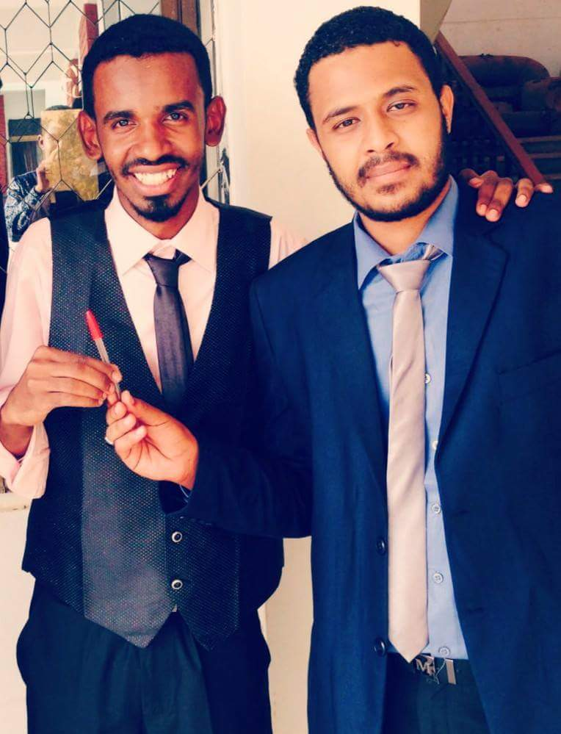  
**Curriculum vitae**

**I-Personal data:**  
**Name:** Fath-elrahman Awad -elkreem Idris Ismail  
**Place of Birth**: Omdurman  
**Date of Birth**: 10 \ 1 \ 1990  
**Social state :** married and I have 2 children

**Address**: Khartoum - Omdurman - Elthura.  
**Current residence:** Elthura ( el- hara 11)  
**Phone:** 0115012530/ 0927284832  
**Grades:**  
**Basic level** : Omar bin al-Khattab modrenSchool   
**Secondary level** : karari Modern Secondary school  
**University**: Omdurman Islamic (November 2006)  
**College**: Pharmacy  
**Specialization**: Clinical Pharmacy  
**Graduation Project**: Prescribing Pattern ofAntidiabetics in type-2DM  
**Graduation Year:** 2011  
**Rate of academic achievement:**  excellent .   
**II-Qualifications**: (see Appedices!!)

**1-B.Sc. Pharmacy First Class Honors**

2- **M. Pharm. degree in clinical pharmacology 2016.**

**3- Certificate of Attending Teaching&Learning Workshop from Educational Development Centre for Health professions,, Faculty of Medicine-University of Khartoum.**

**4.Certificate of Attending Assessment and Evaluation workshop from Educational Development Centre for Health professions,, Faculty of Medicine-University of Khartoum.**

**5. Certificate of Attending workshop entitled Bioinformatics and advanced genomic.**

**6. Certificate of attending The 18th Congress of Scintific Association of Pharmacy Colleges in the Arab World.**

**III-Experience:**  
**Houseship period:** Military hospital (drug supply information center) participate in the research arms Hospital Medical Center (polypharmacy).  
 **National Service**: Omdurman Islamic University College of Pharmacy Pharmacology department.

**Current workplace and places that worked out :**

**1-Elanbiaa pharmacy - popular market Omdurman (1/9/2011-7/6/2012)  
2-Hakim Medical Center Asmar medical –pharmacy - Ambdh h( 10) (15/6/2012- 17/5/2014)**

**3- SEBDO INTERNATIONAL PHARMACY –As manager and pharmacist 1/6/2014 –till now)**

**4-Teaching assistant collaborator at the Faculty of Pharmacy, University of Omdurman Islamic Department of Pharmacology (from 14/2/2012- 1/6/2014).**

**5- post graduate student at OMDURMAN ISLAMIC UNIVERSITY –Pharmacology department (11-2013—2016)**

**6-Teaching Assistant as a formal job from Ministry of Higher education at Omdurman Islamic University -Faculty of pharmacy –pharmacology department( 3/2-2015)**

**7- lecturer at Faculty of pharmacy OIU ,Pharmacology department 2016**

**IV-References:**

**A –Universities Staff.**

1/ Prof. Tareg Elhadia ,, Dean of faculty of Pharmacy,, Africa International University,, phone NO.: 0999600699.

2. Prof.Ahmed Mudawi Musa ,,Professor of Immunology at Institute of Endemic Diseases,,Khartoum University..

2- prof. Abd elwahab Mohammed Elhassan,, Omdurman Islamic University ,, Pharmacology Department,, Phone NO.: 0915137050  
3 / professor/ Mohammed Elfateh Ahmed Omar  
Dean of the Faculty of Pharmacy - University of Alneelin phone number 0912148861  
4 / Dr. Aymun Abdel Ghaffar Associate Professor Head Department of Pharmacology, Faculty of Pharmacy, University of Omdurman Islamic Phone: 0912200725  
5. Dr. Bashir Elsedig ,,Dean of Faculty of Pharmacy ,,Sudan International University,, phone NO.: 0912932418

6 / Prof. Mahmoud Mudawi Tahir  
Associate Professor Omdurman Islamic University - Pharmacology phone number 0918104298

7 / Dr. Azahari alnour elhaj  
Associate Professor of the University of karari/ Military hospital Phone NO. : 0912818300  
8/Dr Mona Abd EL-moneim associated professor (pharmacognosy department) phone No.:09129435200

**B- others**

1. **Awad elkareem Idris Ismail,, manager at Elasfia petroleum company,, 0123022870**
2. **Mohamed Abelgasim ,,pharmacy manager,, 0912237812**

**V-Appendices:**



